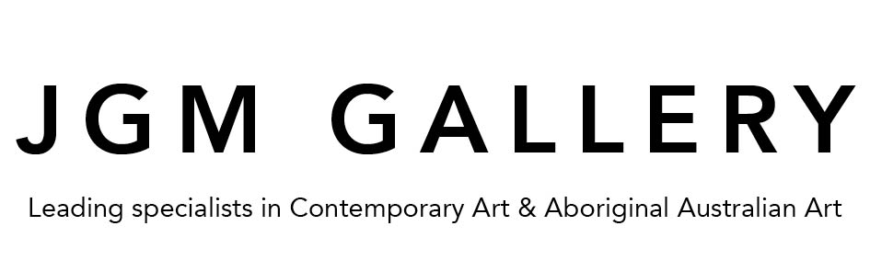

CLOSE DISTANCE
The Tea House Paintings
A solo exhibition of works by contemporary London-based artist Ben Deakin
opens x April – 6 April 2022 at JGM Gallery in Battersea, London

British artist Ben Deakin has a strong connection with mountains. His most recent visit to the Himalayas – the world’s highest mountain range – is the inspiration behind his latest solo exhibition, ‘CLOSE DISTANCE: The Tea House Paintings’, which opens at JGM Gallery on 6 April 2022.

The title of the exhibition plays with the idea of the ‘framed’ perspectives of the snowy Himalayan peaks from inside a Nepalese tea house, and the repetition of patterns in the furnishings, inspired by, among other influences, the designs of British 19th century artist William Morris, from a time when creative ideas were flowing from East to West.

The 10 artworks that form the exhibition – together with x smaller ‘pattern’ works – also offer the viewer a perspective of life at 4,000 metres above sea level. Deakin, who himself grew up among mountains, in England’s Lake District National Park, says that the ‘framed perspectives’ free the viewer to project their own ideas.

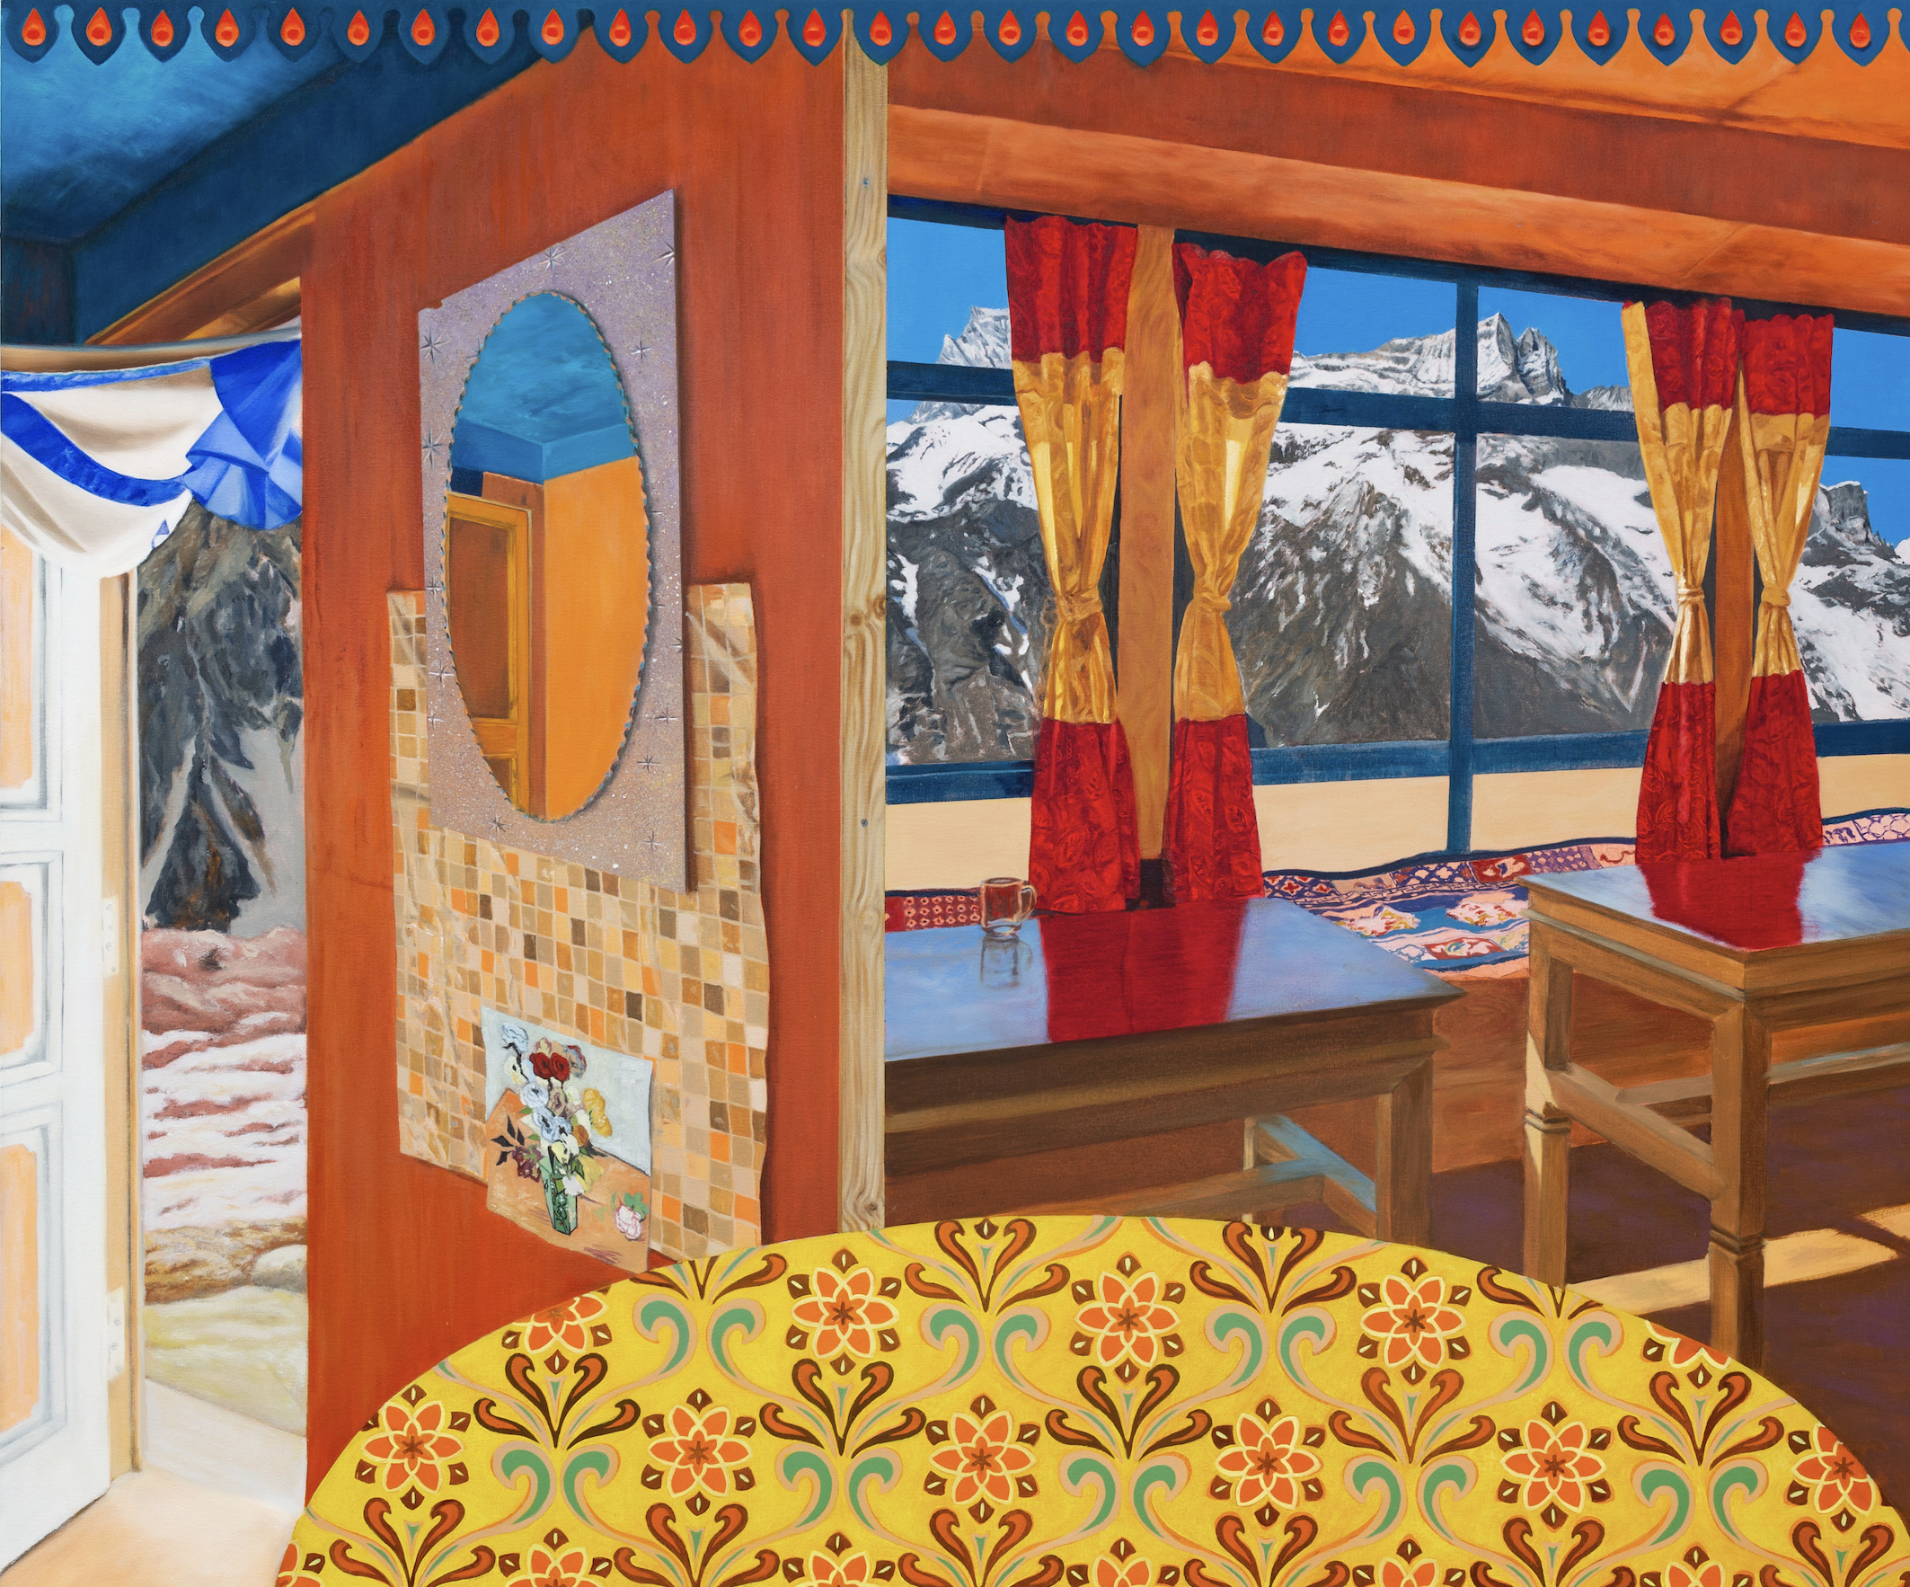
“Recollector’’by Ben Deakin, 2021, Oil on canvas, 125cm x 150cm

Jennifer Guerrini Maraldi, founder of JGM Gallery, herself a mountain lover, says: “We have all experienced that uplifting feeling of being among mountains. This latest series of Ben’s has taken that feeling to a new level, not least through the intensity of his colours – from the deep blue of the skies to the garish vibrancy of the interiors.”

‘CLOSE DISTANCE’ also looks to represent the experience of being in multiple places at once – both inside and outside, and across cultures, says Deakin, which is reflected not only in the William Morris and Art Nouveau-inspired patterns, but also in
the tropical pineapple and the Van Gogh reproduction pinned to the wall.

This latest body of works harks back to Deakin’s travels in the Himalayas in 2019 and was made over 2021 and 2022 in his London studio. Deakin says he has stayed “relatively faithful” to the look of the original tea house. Most notably he has heightened the colour intensity in reference to the garish, highly decorated interiors of the mountain Buddhist monasteries.

The tea houses are in fact ‘lodges’, offering mountain trekkers a basic lodging and shelter from the intense cold, the strong winds and the blistering sun of the Himalayas. “The name ‘tea house’ conjures up a more ‘distant’ world,” explains Deakin about his choice of names.

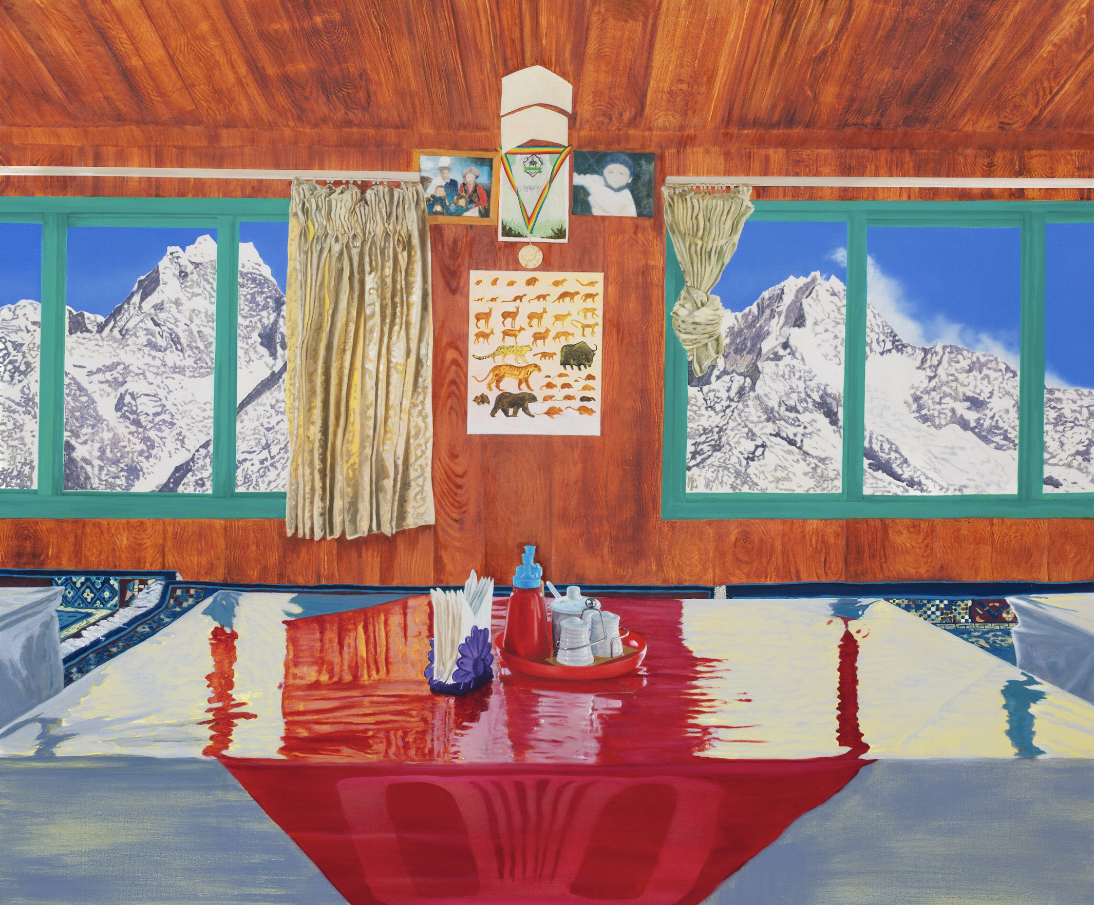

“Emanator” by Ben Deakin, 2022, Oil on canvas, 125cm x 150cm

The view of the mountains from inside the tea house is also a way of making the landscape “relevant” to the viewer, says Deakin, who throughout his career as an artist has always had an interest in landscape painting as an artform.

“Fusing the soft, colourful patterns and interiors with the grand, majestic mountains reflects on the fact that the mountains are completely passive; yet we project so many ideas onto mountains – not least that of the conquering mountaineer trying to prove themselves,” says Deakin.

Not only has Deakin had a long “ongoing connection” with the works of William Morris (his last solo exhibition was inspired by Morris’ book ‘News from Nowhere’), but also with writers such as Robert Macfarlane.

In his book ‘Mountains of the Mind: A history of a fascination’, Macfarlane refers to how mountains return to us a “priceless capacity for wonder” and “urge us to apply that wonder to our own everyday lives.”

In his series ‘CLOSE DISTANCE’, Deakin’s work offers not just ‘repeating’ perspectives but also a large spoonful of ‘wonder’.

ARTIST’S BIO: Ben Deakin (b. 1977) lives and works in London. He studied at Kingston University and gained an MA in Fine Art from Central Saint Martins in 2006. Deakin’s most recent solo exhibitions include: ’Reimagining Nowhere’, The William Morris Society, London (2019) and ‘Seeking News From Nowhere’, The Concept Space, London (2018). His most recent artists residencies include at PADA Studios, near Lisbon (2018) and Joya AiR, in Almería, Spain (2017). Find out more about Ben Deakin.

For further information, or for high-res images for media use, please contact us at the gallery on info@jgmgallery.com or + 44 (0) 207 228 6027.

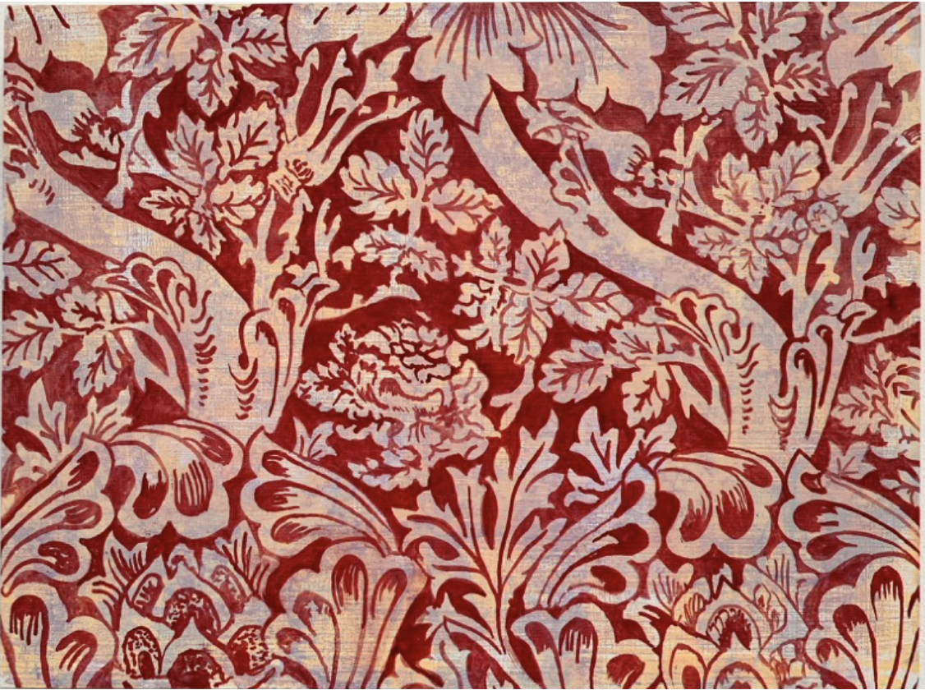
Untitled (red) by Ben Deakin, 2022, Oil on panel, 23cm x 31cm

